Lab Experiment #1

ECE 282 - 002

Friday PM Lab

Carlos Sanchez and Connor Raasch

**Laboratory Experiment #1 Pre-Lab**

1. Write the truth table for two inputs, A and B, for the following gates. Also provide the waveforms for both inputs and all six outputs:

a) NOT b) AND c) OR d) NAND e) NOR f) XOR

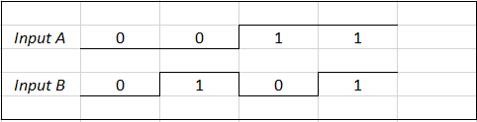

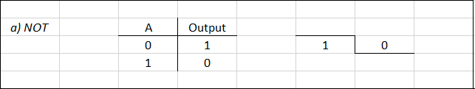

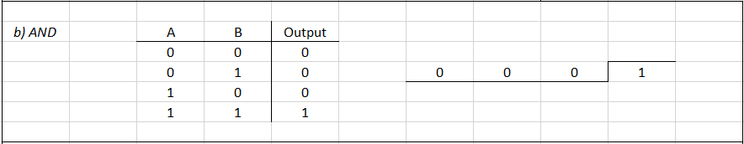

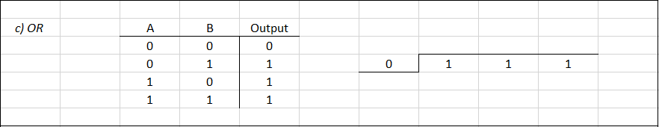

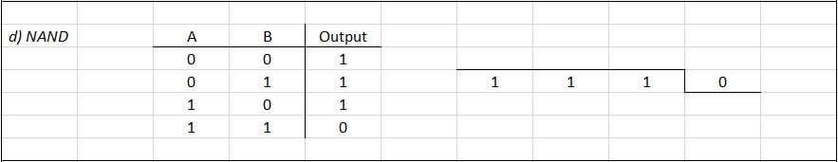

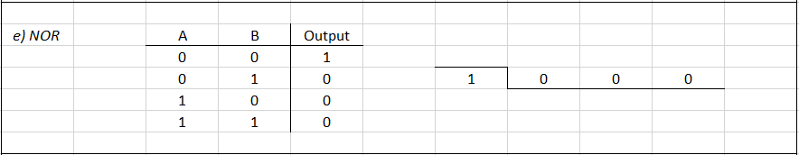

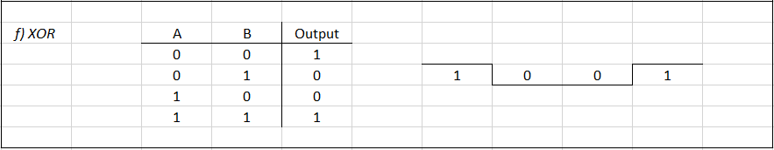

2. Draw the logic diagram (power, ground, pin numbers, part numbers included) for each circuit listed under **Propagation Delay** on p.564 of the textbook.

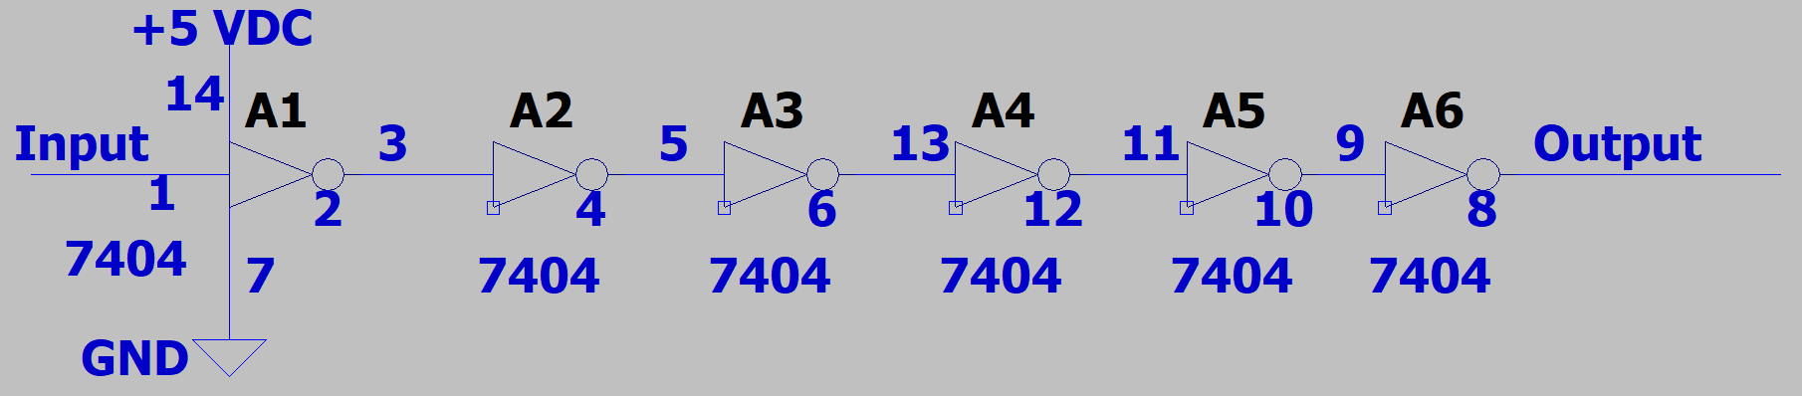

3. Draw the logic diagram (power, ground, pin numbers, part numbers included) for each circuit listed under **Universal NAND Gate** on p.564 of the textbook using only NAND gates.

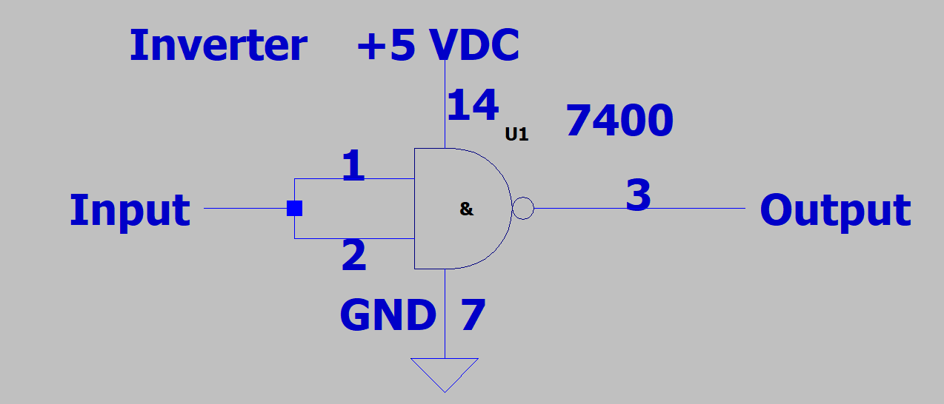

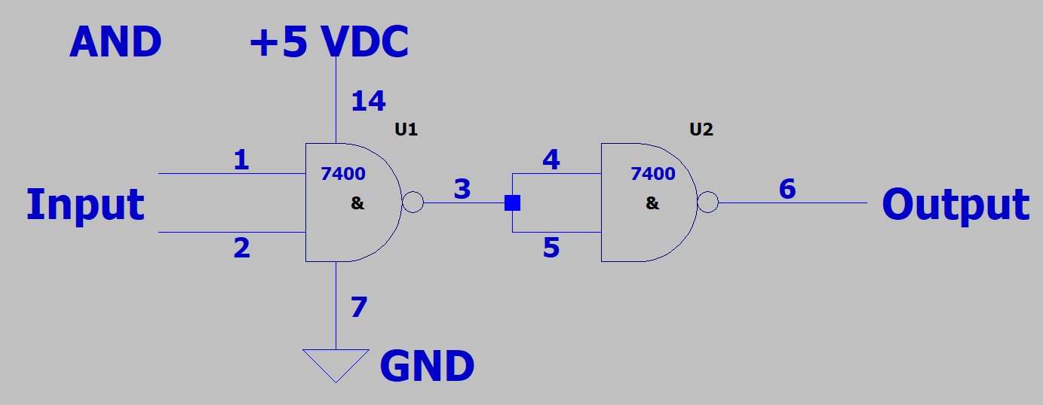

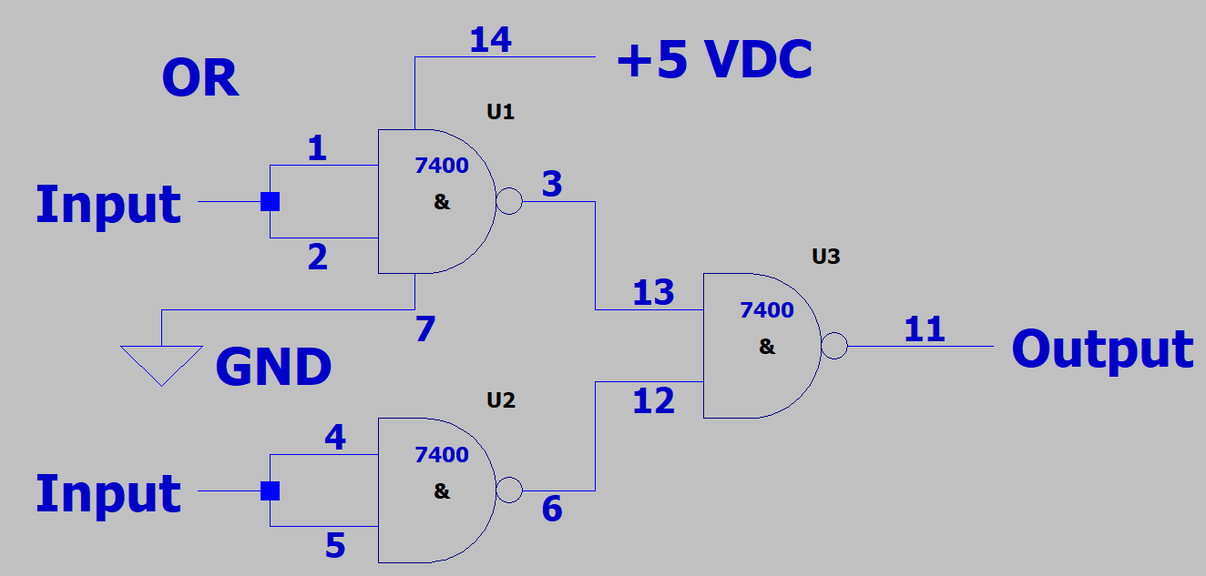

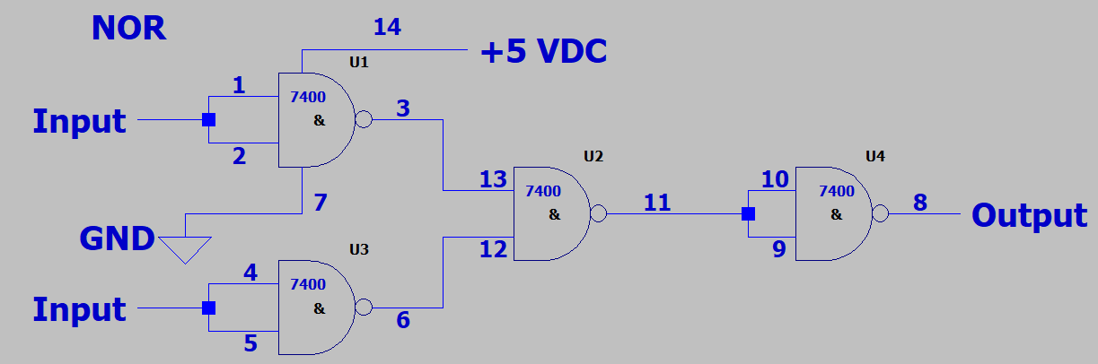

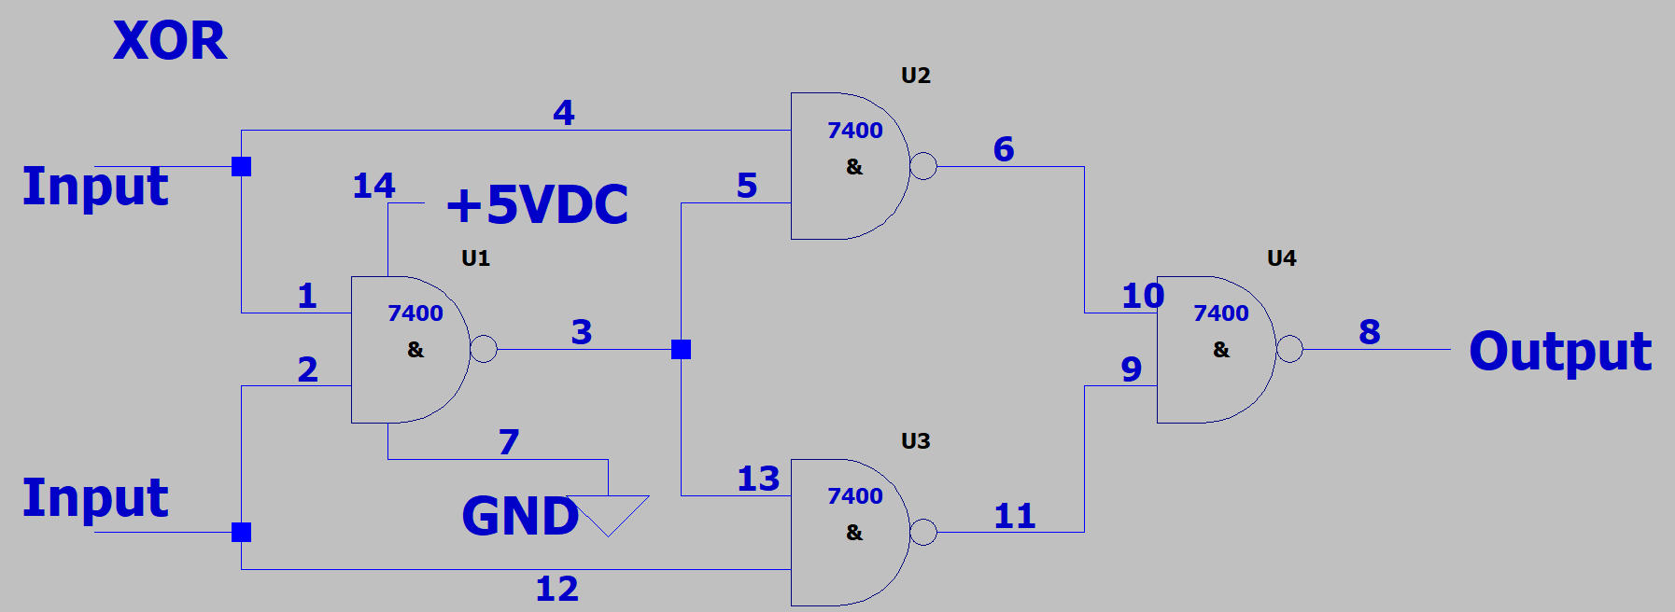

**Laboratory Experiment #1**

1. Work **Binary Count** and **BCD Count** from section 9.2 on pp.560-561 and demonstrate them on the oscilloscope to the TA. Include your circuit diagram as well as a printout of the waveforms of the circuit’s operation using the oscilloscope in the Lab Report.

Binary:

Q0 = Output 1.

Q1 = Output 2.

Q2 = Output 3.

Q3 = Output 4.

BCD:

Q0 = Frequency.

Q1 = Output1.

Q2 = Output2.

2. Work **Propagation Delay** from section 9.3 on p.564 and include in the lab report the truth table or timing diagram for each circuit.

Propagation Delay:

Q0 = Input

Q1 = Output

Δx = 32.000 ns.

Work **Universal NAND Gate** from section 9.3 on p.564 and include in the lab report the truth table or timing diagram for each circuit.

Inv:

Q0 = Input

Q1 = Output

AND:

Q0 = Input

Q1 = Input

Q2 = Output